**Republic of Iraq**

**Ministry of Higher Education and Scientific Research**

**University of Baghdad - College of Science**

**Department of Computer Science**

**Graduation Certificates Issue System**

A Project

Submitted to College of Science, University of Baghdad in Partial Fulfillment of the Requirements for the Degree of B.Sc. in Computer Science

**BY**

Maryaim SH. Mahmood

**Supervisor:**

Assistant Lecturer Ali A. Khalaf

**June - 2023 Dhul Qa’dah-1444**

**Dedication (الاهداء)**

I dedicate this to my loving family, who have been my unwavering pillars of support. Your encouragement, belief in my abilities, and sacrifices have been the driving force behind my accomplishments. This project is a testament to the love and inspiration you have bestowed upon me.

To my dear friends, thank you for being there through thick and thin. Your camaraderie, laughter, and moral support have made this journey memorable. We have shared countless late-night study sessions, brainstorming sessions, and moments of celebration, creating cherished memories that I will forever hold dear.

To my esteemed teachers, your guidance and mentorship have shaped my intellect and nurtured my passion for learning. Your dedication to impart knowledge and ignite curiosity has played a vital role in my personal and academic growth. This project stands as a reflection of your invaluable contributions to my education.

Lastly, to life itself, thank you for presenting me with opportunities, challenges, and experiences that have shaped my character and fueled my ambition. This project symbolizes my commitment to embracing the endless possibilities that lie ahead and making a positive impact in the world.

With deep appreciation and heartfelt dedication,

***Maryaim.***

**Acknowledgements**

Thanks, and appreciation to everyone who helped me in completing this research, especially my family, friends ,and the greatest thanks to my supervisors Assistant Lecturer Ali A. Khalaf , and my honorable doctors during my scientific career at the College of Science in the Department of Computer.

***Maryaim.***

**Abstract**

The Graduation Certificates Issue System is a software solution developed using C# programming language and integrated with a SQL Server database for efficient data storage and retrieval. User authentication ensures secure access to the application. The project aims to automate and streamline the process of managing graduation certifications for educational institutions.

The application provides a user-friendly interface for administrators to manage student records, course information, and generate graduation certifications. It includes features such as user authentication, student management, course management, certification generation, document storage, reporting.

By utilizing the application, administrators can easily add and update student information, track their course completion status, and determine their eligibility for graduation. The system automatically generates graduation certifications for students who meet the predefined criteria, ensuring accuracy and authenticity. The certifications are stored securely, allowing administrators to search and retrieve them as needed.

Overall, the Graduation Certificates Issue System is Desktop Application simplifies the management of graduation certifications for educational institutions, reducing manual efforts, improving efficiency, and ensuring accurate and timely certification generation.

**Table of Contents**

|  |  |
| --- | --- |
| **Title** | **Page No.** |
| ***CHAPTER 1 –*  *General Introduction*** | **9** |
| **1.1 Overview** | **10** |
| **1.2 Project Problem** | **11** |
| **1.3 Project Objectives** | **12** |
| **1.4 Object Organization** | **14** |
| ***CHAPTER 2– Theoretical Background*** | **15** |
| **2.1 Introduction** | **16** |
| **2.2 Hardware Specification** | **16** |
| **2.3 Software Specification** | **16** |
| **2.3.1 Visual Studio** | **17** |
| **2.3.2 C# Language** | **17** |
| **2.3.3 .NET Framework** | **18** |
| **2.3.4 SQL Server** | **19** |
| ***CHAPTER 3- Methodology*** | **21** |
| **3.1 Database creation** | **22** |
| **3.2 Design Form** | **26** |
| ***CHAPTER 4- Result & Discussion*** | **33** |
| **4.1 Introduction** | **34** |
| **4.2 Result and Discussion** | **34** |
| ***CHAPTER 5- Conclusion & Future work*** | **35** |
| ***5.1. Conclusion*** | **36** |
| ***5.2 Future Work*** | **36** |

**List of Figures**

|  |  |
| --- | --- |
| **Table Name** | **Page No.** |
| **Figure(3.1) Start Form** | 18 |
| **Figure(3.2) Department Selection Form** | 19 |
| **Figure(3.3) The Searching By Name or Graduation Year Form** | 20 |
| **Figure(3.4) Adding & Deleting for Departments & Years Form** | 21 |
| **Figure(3.5) Certification Document Generated** | 22 |
|  |  |

**List of Tables**

|  |  |
| --- | --- |
| **Table Name** | **Page No.** |
| **Table(3.1) Subject Table Creation & Design** | 14 |
| **Table(3.2) Departments Table Creation & Design** | 15 |
| **Table (3.3) Graduation Year Table , Creation and Design** | 16 |
| **Table (3.4) Students Information and Grades, Creation and Design** | 17 |

**List of Abbreviations**

|  |  |
| --- | --- |
| SQL | Structured Query Language |
| DLL | dynamically linked library |
| .NET | network enabled technology |
| IDE | integrated development environment |
| CLR | common language runtime |
| OOP | object-oriented programming |
| IDE | integrated development environment |

**CHAPTER ONE**

**Introduction**

**CHAPTER**  **ONE**

**General Introduction**

* 1. **Overview**

The Graduation Certificate Issue system is a software solution developed using C# programming language and integrated with a SQL Server database. It is designed to automate and streamline the process of managing graduation certifications for educational institutions.

* **Key Features:**

1. User Authentication: The application provides secure user authentication to ensure that only authorized personnel can access and manage graduation certifications.
2. Student Management: The application allows administrators to manage student records. They can add new students, update existing information, and view student details such as personal information, course completion status, and graduation eligibility.
3. Course Management: Administrators can define and manage the courses offered by the institution. They can add new courses, update course details, and specify graduation requirements for each course.
4. Certification Generation: The application automates the generation of graduation certifications based on predefined criteria. Once a student meets all the graduation requirements for a specific course, the system generates a certification document with relevant details and digitally signs it for authenticity.
5. Document Storage: The application stores and manages all generated graduation certifications securely. Administrators can search and retrieve certifications based on student details, course information, or other relevant criteria.
6. Reporting and Analytics: The application provides reporting and analytics features to gain insights into graduation certifications. Administrators can generate reports on the number of certifications issued, graduation rates, course popularity, and other relevant metrics.

* **Technology Stack:**
* Programming Language: C#
* Database: Microsoft SQL Server.
* User Interface: Windows Forms or WPF (Windows Presentation Foundation).
* Data Access: ADO.NET or Entity Framework.
* Reporting: Crystal Reports.

* **Deployment:**

The Graduation Certificate Issue System which is Desktop Application can be deployed on individual computers or on a local network within the educational institution. It requires the installation of the necessary software components, such as the .NET Framework, SQL Server, and any additional libraries or frameworks used in the development.

Overall, the Graduation Certificate Issue System is a Desktop Application that simplifies the management of graduation certifications for educational institutions, reducing manual efforts, improving efficiency, and ensuring accurate and timely certification generation.

**1.2 Project Problem**

While developing the project using C# and SQL Server, we may encounter several challenges or problems. Here are some common issues that we may face:

1. Database Design: Designing an efficient and scalable database schema can be challenging. Ensuring proper normalization, establishing relationships between tables, and optimizing query performance require careful consideration .
2. Security: Protecting sensitive student and certification data is of utmost importance. Implementing secure authentication mechanisms, preventing SQL injection attacks, and securing data transmission require thorough attention to ensure the application's security.
3. User Interface Design: Designing an intuitive and user-friendly interface can be challenging. Ensuring proper layout, navigation, and responsiveness to accommodate various screen sizes and resolutions is essential for a seamless user experience.
4. Performance Optimization: As the application grows and handles a significant amount of data, performance optimization becomes critical. Optimizing database queries, indexing, and implementing caching strategies can improve application responsiveness and scalability.
5. Error Handling and Logging: Implementing robust error handling mechanisms and logging functionalities is essential for troubleshooting and identifying issues during application usage. Proper exception handling and logging can help diagnose and resolve problems effectively.

These are some common problems that we may encounter while developing a Graduation Certification Desktop Application using C# and SQL Server. It is essential to plan and address these challenges proactively to build a robust and reliable application.

**1.3 Project Objectives**

The objectives for the admin module of a Graduation Certificate Issue System using C# and SQL Server can include the following:

1. User Management: Implement an admin interface to manage user accounts, including creating, updating, and deleting user profiles for administrators, instructors, and staff members.
2. Program and Course Management: Allow admins to manage programs, degrees, and courses offered by the institution, including adding, editing, and archiving program information and course details.
3. Graduation Requirements Configuration: Provide an interface for admins to define and configure the graduation requirements for each program or degree, including specifying required courses, credit hours, GPA thresholds, and any additional criteria.
4. Document Verification and Approval: Enable admins to review and verify student documents submitted for graduation certification, including transcripts, course completion certificates, and other necessary records. Admins should have the ability to approve or reject documents based on predefined criteria.
5. Committee Management: Allow admins to create and manage committees responsible for reviewing student graduation applications, assigning committee members, and overseeing the approval process.
6. Workflow Management: Implement a workflow system that allows admins to define the stages and steps involved in the graduation certification process, including document submission, committee review, and final approval.
7. Reporting and Analytics: Provide admins with reporting and analytics features to generate statistical reports, monitor graduation rates, track program completion progress, and gather insights about the overall performance of the graduation certification system.

These objectives focus on the specific needs and responsibilities of the admin module within the Graduation Certificate Issue System, enabling administrators to efficiently manage the certification process, review student documents, track progress, and ensure accurate and timely graduation certifications.

**1.5 Project Organization**

Project Outlines

* **Chapter two** presents the theoretical concepts about desktop application, and a brief description about the used technologies such as visual studio, .NET Framework and SQL Server.
* **Chapter three**  introduces the implementation of the proposed system which is implemented by using Visual Studio Community 2022 Version 17.5.5.
* **Chapter four** gives and illustrates the general result for the Graduation Certificate Issue System desktop application.
* **Chapter five** summarizes the conclusions and presents the future developments to the designed desktop application.

***CHAPTER TWO***

*Theoretical Background*

**CHAPTER TWO**

**Theoretical Background**

**2.1 Introduction**

In this chapter, before starting the design and implementation for the desktop application

Of this project, I find it necessary to clarify some of the concepts and technologies used and

and to master a small set of fundamental skill. We divide the technologies into two sections ,

the hardware section and the software section .

**2.2 Hardware specifications**

✓ CPU: Intel(R) Core(TM) i5-10210U CPU (1.60GHz)

✓ RAM: 8.0 GB

✓ H.D: Lexar 512 GB SSD

**2.3 Soft wares**

The used soft wares are :

✓ Visual Studio community (VS)

✓ C# Language

✓ .NET Framework

✓ SQL Server

**2.3.1 Visual Studio Community (VS)**

A fully-featured, extensible, free IDE for creating modern applications for Android,

iOS, Windows, as well as web applications and cloud services.

* **Features :**
* **Flexibility : Build apps for any platform.**
* **Productivity :Designers, editors, debuggers, profilers, in one single tool.**
* **Ecosystem :Access to thousands of extensions.**
* **Languages :Code in C#, Visual Basic, F#, C++, HTML, and more.[3]**

**2.3.2 C# Language**

* **What is C# ?**
* C# is a popular language for a variety of reasons, but mainly because it's multi-paradigm language that is versatile, fairly easy to learn and object-oriented. With so many different programming languages to choose from, we thought we’d give you a proper introduction to C# so you can decide if it’s the right fit for your next project.
* C# is a modern, general-purpose programming language that can be used to perform a wide range of tasks and objectives that span over a variety of professions. C# is primarily used on the Windows .NET framework, although it can be applied to an open source platform. This highly versatile programming language is an object-oriented programming language (OOP) and comparably new to the game, yet a reliable crowd pleaser.[3]
* **C# Features**
* **Simple.**
* **Modern programming language.**
* **Object oriented.**
* **Type safe.**
* **Interoperability.**
* **Scalable and Updateable.**
* **Component oriented.**
* **Structured programming language.**
* **Rich Library.**
* **Fast speed.**

**2.3.3 .NET Framework**

* .NET Framework is a software development framework for building and running applications on Window.
* .NET Framework is part of the .NET platform, a collection of technologies for building apps for Linux, mac OS, Windows, iOS, Android, and more.
* **Features of .NET Framework :**

1. Cross- Language Interoperability: Language interoperability is the ability of a code to interact with another code that is written by using a different programming language irrespective of the language in which it is created. Language interoperability can help maximize code reuse and improve the overall efficiency of the development process.
2. Multi-language Support: The .NET platform supports many programming languages. A new compiler must be implemented for each language, FrameworkV2.0 supports up to 45 languages.
3. Automatic Resource Management: In the common language runtime (CLR), the garbage collector serves as an automatic memory manager.

* The .NET Framework’s garbage collector manages the allocation and release of memory for our application. Each time we create a new object, the common language runtime allocates memory for the object from the managed heap.
* The runtime automatically handles object layout and manages references to objects, releasing them when they are no longer being used. This automatic memory management resolves the two most common application errors, memory leaks and invalid memory references.

1. Type Safety : Data structure in .NET supported languages has the same layout. This means that some code can consume types and instances declared in other languages.
2. Debugging: A debugger is a computer program that lets you run your program, line by line and examine the values of variables or look at values passed into methods and let you figure out why it isn’t running the way you expected it to.
3. Elimination of DLL Hell :DLL Hell happens when multiple applications attempt to share a common DLL, .NET Framework solves this problem by allowing multiple versions of the same DLL to coexist.
4. Security :Managed components are awarded varying degrees of trust, depending on a number of factors that include their origin (such as the Internet, enterprise network, or local computer). This feature empowers a developer to determine whether a managed component performs file-access operations, registry-access operations, and other sensitive functions or not.[4]

**2.3.4 SQL Server**

Microsoft SQL Server is one of the main relational database management systems on the market that serves a wide range of software applications for business intelligence and analysis in corporate environments.[2]   
  
Based on the Transact-SQL language, it incorporates a set of standard language programming extensions and its application is available for use both on premise and in the cloud.

* **SQL Server Features**

**1.Intelligence on all your data with Big Data clusters:** being able to query your entire data estate from SQL Serve to Oracle without replication.  
**2. Choice of Language and Platform:** From Windows or Linux, to Kubernetes deployments.  
**3. Intelligent database capabilities:** in-memory, persistent memory support, in-memory optimized temped.  
**4. Data encryption and compliance:** Its data protection, monitoring and classification system has made it one of the top most secure platforms according to the National Institute of Standards and Technology database for 9 years.  
**5. Mobile BI and scalability:** Allowing you to easily integrate your database management systems with any device and Azure services for better performance and analytical capabilities on data.[1]

***CHAPTER THREE***

***Methodology***

**CHAPTER THREE**

**Methodology**

**3.1 Introduction**

This chapter explored the design and implementation Graduation Certificate Issue System.

**3.2 Database Creation**

In our project there are four main table we deal with, these are Subjects, Departments, Graduation Years and Students info as shown below and next pages.

|  |
| --- |
| **Subjects Table** |
|  |
|  |

**Table(3.1) Subject Table Creation & Design**

|  |
| --- |
| **Departments Table** |
|  |
|  |

**Table(3.2) Departments Table Creation & Design**

|  |
| --- |
| **Graduation Year Table** |
|  |
|  |

**Table (3.3) Graduation Year Table , Creation and Design**

|  |
| --- |
| **Students Information and Grades Table** |
|  |
|  |

**Table (3.4) Students Information and Grades, Creation and Design**

**3.3 Design Form**

The design include multiple form such as

* 1. **Start Form :** this form include the institution name and logo as well as two main buttons, one for user and the other is for administration.

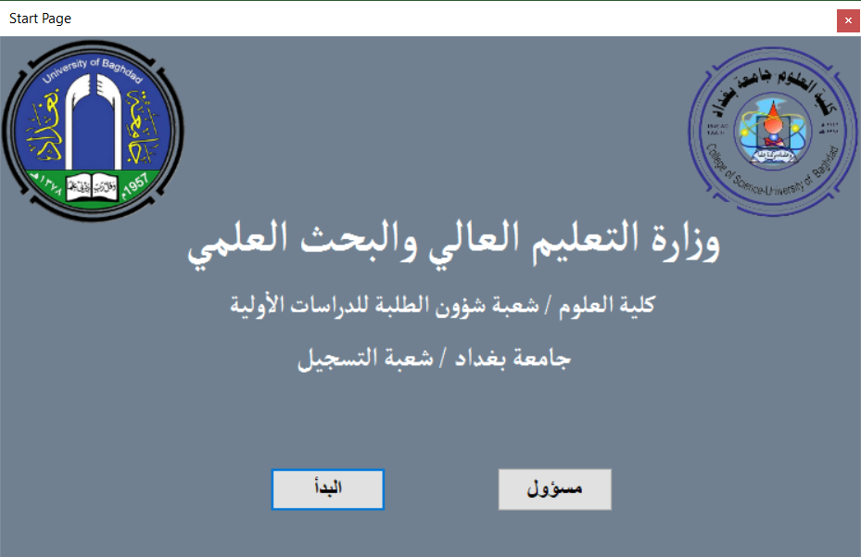

**Figure(3.1) Start Form**

* **Start User Button Code:**

private void btn_user_Click(object sender, EventArgs e)

{

Form3 log = new Form3();

log.Show();

}

* **Admin Button Code :**

private void btn_admin_Click(object sender, EventArgs e)

{

Form2 log = new Form2(); log.Show();

}

* 1. **Departments Form:** it include a drop down list for all departments in college of science, Back button to the previous form and next button to the next form

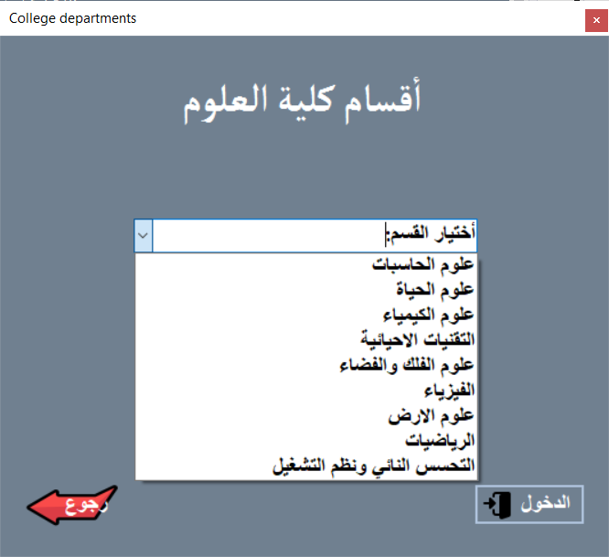**Figure(3.2) Department Selection Form**

* **Login Button Code :**

private void btn_login_Click(object sender, EventArgs e)

{

if (com_department.Text=="")

MessageBox.Show("يرجى اختيار القسم");

else

{

Form4 log = new Form4();

log.Title_Dep.Text = com_department.Text; log.Show(); this.Close();

}

}

* **Back Button Code :**

private void btn_back_Click(object sender, EventArgs e)

{

Form1 log = new Form1(); log.Show(); this.Close();

}

* 1. **Searching Form :** this form include searching for graduation certification either by student name or year of graduation using search button, drop down list for year, text box for student name, data grid view for viewing the certification , and last button for printing the certificate suing crystal report.

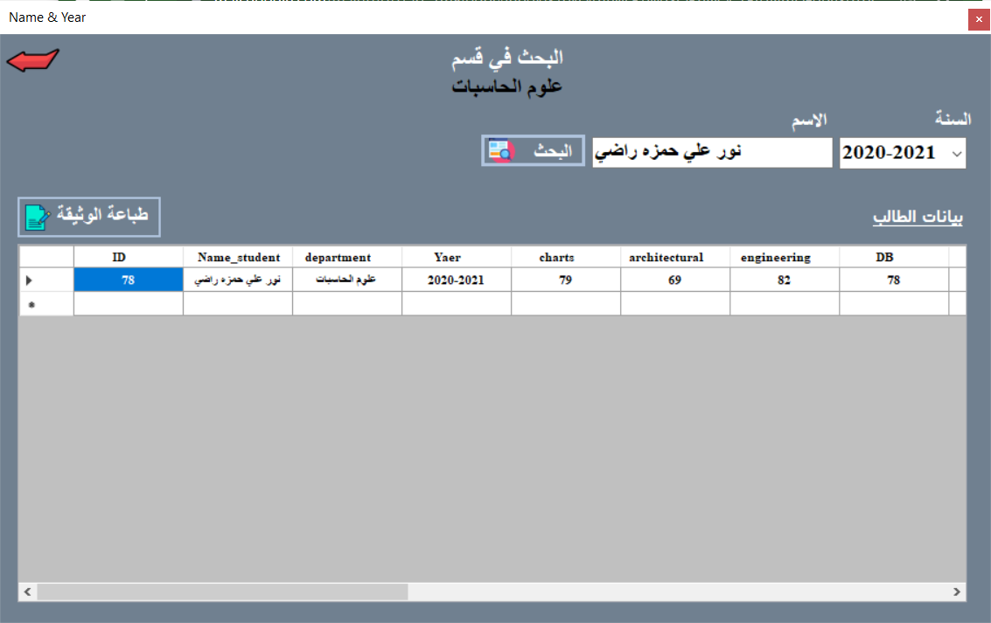

**Figure(3.3) The Searching By Name or Graduation Year Form**

* **Search Button code:**

private void btn_search_Click(object sender, EventArgs e)

{

try

{

Search();

panel1.Visible = true;

dataGridView1.Visible = true;

}

catch (Exception)

return;

}

* **Print Button Code :**

private void btn_print_Click(object sender, EventArgs e)

{

con.Close();

con.Open();

SqlCommand cmd = new SqlCommand("select * from T_Student where Name_student = '" + txt_name.Text + "'", con);

SqlDataAdapter da = new SqlDataAdapter(cmd);

DataSet ds = new DataSet();

da.Fill(ds, "T_Student");

CrystalReport1 cr1 = new CrystalReport1();

cr1.SetDataSource(ds);

this.crystalReportViewer1.ReportSource = cr1;

this.crystalReportViewer1.Refresh();

con.Close() ;

crystalReportViewer1.PrintReport();

}

* 1. **Administration Form** : this form include adding and deleting both of department and years as well as authenticate before deleting.

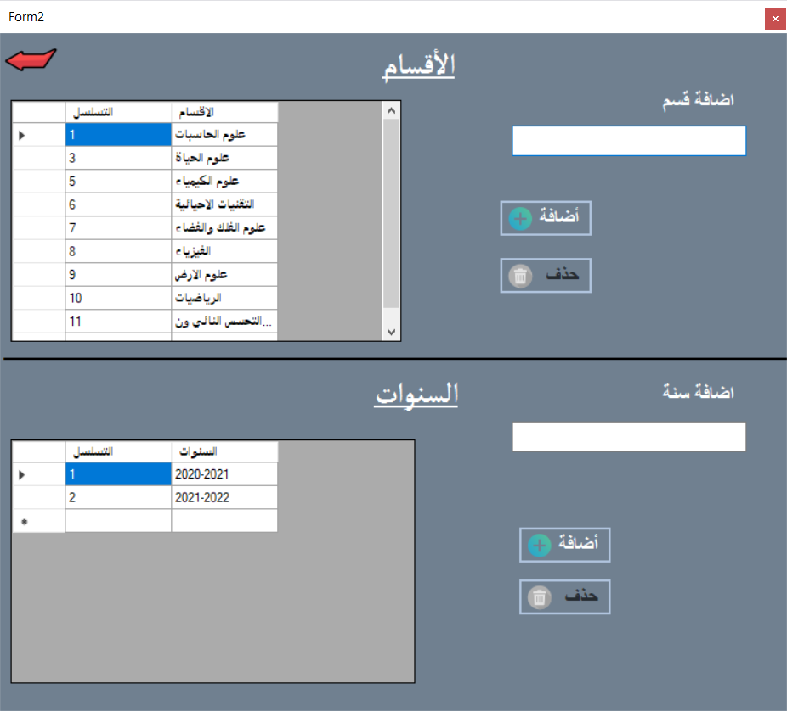

**Figure(3.4) Adding & Deleting for Departments & Years Form**

* **Adding Department Button Code :**

private void btn_add1_Click(object sender, EventArgs e)

{

if (txt_department.Text == "")

{

MessageBox.Show("يرجى كتابة اسم القسم");

}

else

{

try

{

cmd = new SqlCommand("insert into T_departments (departments) values (@Dep)", con);

cmd.Parameters.AddWithValue("@Dep", txt_department.Text);

con.Open();

cmd.ExecuteNonQuery();

con.Close();

MessageBox.Show("تم الاضافة بنجاح");

txt_department.Clear();

load_data1();

}

catch (Exception)

{

return;

}

}

}

* **Deleting Department Button Code :**

private void btn_delete1_Click(object sender, EventArgs e)

{

string message = "هل انت متأكد من الحذف؟" ; string title = "حذف قسم";

MessageBoxButtons buttons = MessageBoxButtons.YesNo;

DialogResult result = MessageBox.Show(message, title, buttons);

if (result == DialogResult.Yes)

{

con.Close();

cmd = new SqlCommand("Delete From T_departments Where ID=@id", con);

cmd.Parameters.AddWithValue("id", OleDbType.Integer).Value = ID_1.Text;

con.Open(); cmd.ExecuteNonQuery();

con.Close(); load_data1();

MessageBox.Show("تم الحذف بنجاح");

T_1.Visible = false;

Pass_1.Visible = false;

btn_delete1.Enabled= false;

}

else

return;

}

* The figure below represent the printed certificat :

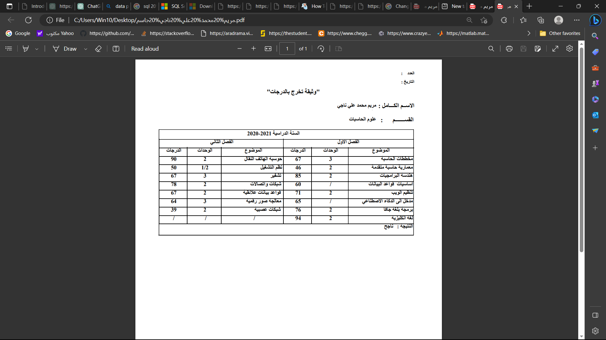

**Figure(3.5) Certification Document Generated**

***CHAPTER FOUR***

***Results and Discussion***

**CHAPTER FOUR**

**Results and Discussion**

**4.1 Introduction**

In this part, I will talk about the results that I encountered or knew about through the project, as well as I will discuss the project clearly.

**4.2 Results And Discussion**

1. Non-automated work is not commensurate with the current development and leads to delays and loss of efforts.
2. Programs must be established when students are accepted. maintain it annually with grades, and do not work on it when graduates in order to reduce the time for issuing documents.
3. Higher departments must allocate financial and human resources to create a scalable software environment, thus reducing time and effort and providing a service worthy of institutions.
4. Specialized software staff should be provided and not be involved in administrative work and be asked to manufacture programs at the same time.

***CHAPTER FIVE***

***Conclusions and Future works***

**CHAPTER FIVE**

**Conclusions and Future works**

**5.1 Conclusions**:

The conclusion of the project is a Desktop Application System for educational institution to generate students graduation certifications in Arabic .it helps all authorize end-users to access it at anytime and anywhere, so helps to reduce the time and effort.

**5.2 Future Works:**

We can enhance this system by doing some functionalities such as:

1. Data integrity and security: The system could ensure the integrity and security of student data by using appropriate database design, data validation, and access control measures.
2. Making it Website.
3. Used within Intranet.
4. Submission of students to obtain the document can be done electronically with fees.
5. English language included.

**References**

|  |  |
| --- | --- |
| Material Type | Citation |
| Book | [1] Ross Mistry and Stacia Misner : Introducing Microsoft SQL Server 2014.  [2] Dušan Petkovic : Microsoft SQL Server 2019: A Beginner's Guide , 7’th ed. |
| Webpage | [3] C#. Available <https://technosmarter.com/csharp/features>  Visited : 30/5/2023  [4] .NET Framework . Available  <https://www.softlogicsys.in/features-of-dotnet/> Visited: 31/5/2023  [5] Visual Studio Community. Available <https://visualstudio.microsoft.com/vs/community/> Visited: 2/6/2023 |

**المستخلص**

نظام إصدار شهادات التخرج هو حل برمجي تم تطويره باستخدام لغة برمجة C # مع قاعدة بيانات SQL Server لتخزين واسترجاع البيانات بكفاءة. تضمن مصادقة المستخدم الوصول الآمن إلى التطبيق. يهدف المشروع إلى أتمتة وتبسيط عملية إدارة شهادات التخرج للمؤسسات التعليمية**.**

يوفر التطبيق المكتبي واجهة سهلة الاستخدام للمسؤولين لإدارة سجلات الطلاب ومعلومات الدورة وإنشاء شهادات التخرج. يتضمن ميزات مثل مصادقة المستخدم ، وإدارة الطلاب ، وإدارة الدورة التدريبية ، وإنشاء الشهادات ، وتخزين المستندات ، وإعداد التقارير.

من خلال استخدام التطبيق ، يمكن للمسؤولين إضافة معلومات الطالب وتحديثها بسهولة وتتبع حالة إكمال الدورة وتحديد أهليتهم للتخرج. يقوم النظام تلقائيًا بإنشاء شهادات التخرج للطلاب الذين يستوفون المعايير المحددة مسبقًا ، مما يضمن الدقة والمصداقية. يتم تخزين الشهادات بشكل آمن ، مما يسمح للمسؤولين بالبحث عنها واستردادها حسب الحاجة.

بشكل عام ، نظام إصدار شهادات التخرج هو تطبيق مكتبي يبسط إدارة شهادات التخرج للمؤسسات التعليمية ، ويقلل من الجهود اليدوية ، ويحسن الكفاءة ، ويضمن الحصول على شهادات دقيقة وفي الوقت المناسب.

**جمهورية العراق**

**وزارة التعليم العالي والبحث العلمي**

**جامعة بغداد ـ كلية العلوم**

**قسم علوم الحاسوب**

**نظام إصدار شهادات التخرج**

**مشروع**

**مقدم الى قسم علوم الحاسوب في كلية العلوم ـ جامعة بغداد**

**كجزء من متطلبات نيل شهادة البكالوريوس**

**في علوم الحاسوب**

**من قبل**

مريم شاكر محمود حبيب

**بأشراف**

المدرس المساعد علي عبد الرحمن خلف

**حزيران- 2023 ذو القعدة- 1444**